GUI printouts:



GUI as it comes up when program starts.



GUI with Bold text set to “on”.

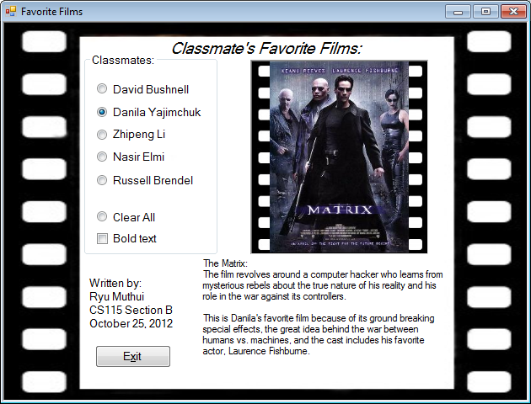

GUI with Bold text set to “off”.